I wish create a function for tracking of all repack work order to their shipment order (packing material), wave no, completed state (when the work order is closed) and shipment order completed (ship wave of repacking material). The format is similar to kit order management

FUNCTION NEED
LOAD - to load all newly created work order into the master screen
CREATE - to create shipment order
ALLOCATE - to allocate repacking material
SHIP WAVE - to ship wave repack material
MASTER SCREEN
- BAX to created repack work order as usual and save
- In new function, REPACK ORDER MANAGEMENT, Ivy will need to press load and the newly repack work order will appear, in master screen the following information will appear
    - Repack Work order no
    - Shipment no.
    - Wave no.
    - Qty
    - Order date
    - Completed status (repack completion)
    - Allocation status (repack allocate status)
    - Shipped status(material shipped)
SUB-SCREEN
  - Like the Kit work order , ivy click on the work order no. and a sub screen will appear and the following information is in the sub screen
    - Packing material
    - CREATE button to create shipment order, wave
    - ALLOCATE button to allocate the packing material
    - SHIPWAVE button to ship wave the repack material
  - Ivy will click on create button , to create a shipment order and wave no that will automatically load into the master screen
  - Ivy will click on allocate button, to allocate repack material
    - If allocation is complete, ALLOCATED STATUS to show full
    - If allocation is not complete(not enough material)ALLOCATED STATUS to show PARTIAL
  - REPACK work order completed
    - Ivy to close job , COMPLETED status to show Completed
    - Ivy to allocate again if partial material are allocated
    - Ivy to click on close to ship wave, (also to close job in Value added service)

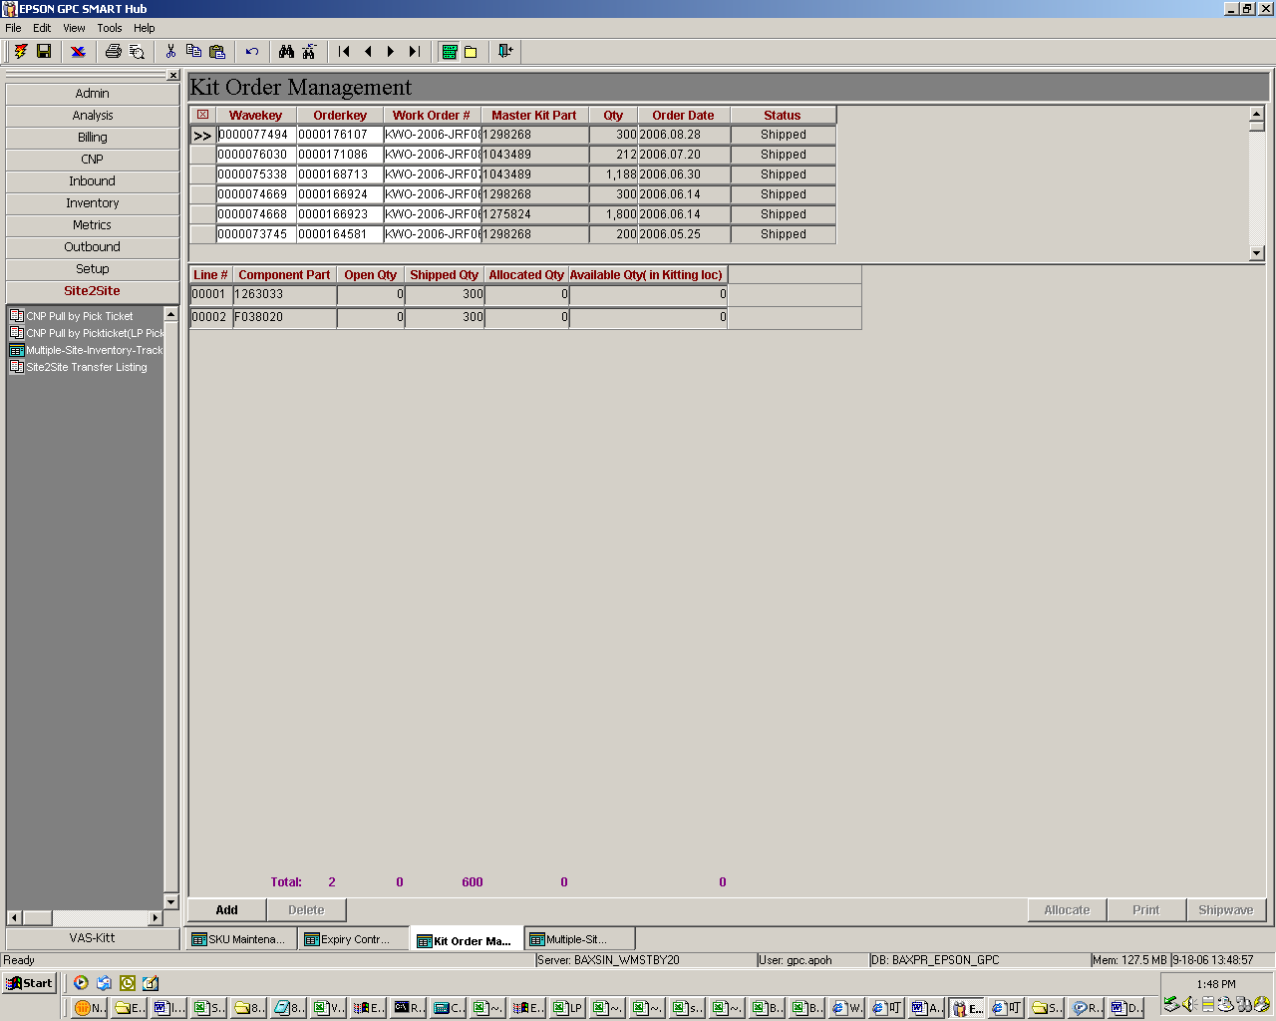
Master screen
Sub-screen.

